Drugs and Alcohol Testing- (Vehicle Accident) Response Procedure for Site Managers
1. Immediate Response After an Accident
- Step 1: Ensure the scene is safe and that any injured individuals receive medical attention.
- Step 2: Notify your Line Manager and HR immediately.
- Step 3: Contact Randox Testing Services to initiate a post-accident drug and alcohol test.
  - Refer to the attached call script for required details and protocol.
  - Ensure testing is arranged as soon as reasonably practicable.

2. Drug & Alcohol Test Administration
- Cooperate fully with the Randox technician during sample collection.
- Ensure the employee being tested is treated respectfully and remains supervised until results are communicated.
- Document the time of the incident, when Randox was contacted, and when testing took place.

3. In Case of a Failed Test
- If an employee fails the drug or alcohol test:
  - Immediately suspend the individual on full pay pending further investigation.
  - Inform HR and SMT without delay.
  - Complete an incident and suspension report.

4. Handover to Senior Management Team (SMT)
- The SMT will take over case management on the next working day.
- All documentation, including:
  - Incident report
  - Suspension notice
  - Randox report should be handed over to SMT or uploaded to the central HR system by the end of the current working day.

5. Training and Compliance
- All site managers and stand-in supervisors must receive documented training on:
  - Contacting Randox
  - Applying suspension protocols
  - Using the provided call script
- Training should be refreshed annually and upon any process updates.
- Attendance and completion of training must be recorded and stored in the Training Matrix.

📎 Attachments
- Randox Call Script
- Suspension Notification Template
- Incident Report Template

Signed: 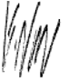
Gary Nourse
Director
28/07/25

NW-F-02 
Accident/Incident/Near-Miss Report form
This report must be sent to your Line Manager within 12 hours of the accident
&
Site Managers to send to Head Office within 24 hours

About Person who had Accident:
Employee Name : |  | Date: |  | Time of Accident
Employee ID/Payroll:  Age :  Sex : |  | Job Title:
Manager/Supervisor : |  | Site Employed

Brief Description of Accident

Near miss (NM) details

Date of NM: / / Time of NM :

Name(s) of Nationwide Staff involved :

Name(s) of client staff involved :

Position i.e. employee, visitor, contractor other:

Location of NM and details of any machinery involved

Diagram/drawing

LT125

WA
W
LT668

Bus wash

Parked buses

Client Vehicle Damage

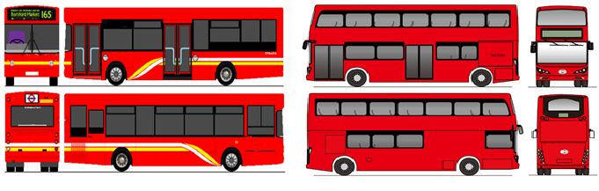

(Bus 2)

Third Party Vehicle Involvement Yes /No (cross out as appropriate)

Full name: Contact Number:

Address: Vehicle Registration:

Description of involvement:

Damage to third party vehicle:

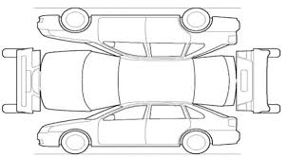

Photographic Evidence Collected: (YES/NO)

Further Details

CCTV available (YES/NO) Date requested (---/----/-------)

Accident reported to client: (YES

Client name: Client Ref/Report No:

Client/Person reported details too: Time Reported:

Phone:

Email:

Personal Injury: NO (delete as applicable)

Description:

Paramedic /Ambulance called :NO

Witness Details

Witness Name : Witness Employed By :

Witness Job Title:

Contact Details:

Address:

Mobile Phone: Home Phone:

Email Address:

Witness Statement:

Acknowledgement of Accident Report
Employee Signature | Date
Manager Signature | Date
Witness Signature (IF APPLICABLE) (if a witness does not wish to sign, please complete with what information that you know) | Date

The information completed in this form is to be true and factual and is the property of Nationwide and is not to be copied to anyone outside of the organization without written permission from Senior Management at Nationwide.

This form must be submitted by Site Manager to Risk and Safety Manager at Nationwide Head Office within 24 hours of the accident / incident / near-miss please send to
Incidents@nationwidefm.com>

