

COSHH ASSESSMENT SHEET
Date of Assessment: 21st July 2026
Assessment No: CSH 43
Assessor: Stephen McCaffrey
Overall Assessment Rating of Risk [ √ ] Low [√ ] Medium [ ] High [ ]

Work Activity: |  |  |  |  |  |  |  |  |  |  | Floor polishing
Persons at Risk: |  |  |  | User [√] Colleagues [√] Contractors [ ] Public [ ] Others [ ]
Name of Hazardous Substance: |  |  |  |  | Mexapol
Manufacturer (address/tele no): |  |  |  |  | Evans Vanodine International plc,  Brierley Road, Walton Summit, Preston, UK. PR5 8AH  01772 322 200
SDS Version: |  |  |  |  | 12
Supplier (address/tele no): |  |  |  |  | Thamesmead Business Services  Unit 4, The Interchange, Wested Lane, Swanley, BR8 8TE  Telephone: 020 3814 1974
Hazard data sheet attached: |  |  |  |  | Yes [ √ ] No [ ]
Description/colour: |  |  |  |  | White
 | Container size in litres/kg |  |  |  | 20  litre/kg |  |  | 10  litre/kg |  |  |  | 5 litre/kg |  |  | >litre/kg |  | < litre/kg |  | Other
 | (tick as appropriate) |  |  |  |  |  |  |  |  |  |  | √
HAZARD (tick all that apply)
 | 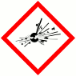 | 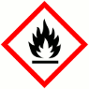 | 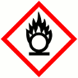 |  |  |  | 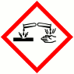 |  | 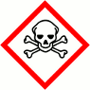 |  |  |  | 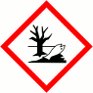 |  |  |  | 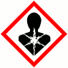 |  | 
 | Explosive (Symbol: exploding bomb) | Flammable (Symbol: flame) | Oxidising (Symbol: flame over circle) |  |  |  | Corrosive (Symbol: Corrosion) |  | Acute toxicity (Symbol: Skull and crossbones) |  |  |  | Hazardous to the environment (Symbol: Dead tree and fish) |  | Health hazard/Hazard ous to the ozone layer (Symbol: Exclamation mark) |  | Serious health hazard (Symbol: health hazard) |  | Gas under pressure (Symbol: Gas cylinder)
Known exposure levels:  W.E.L. (where applicable) |  |  |  |  |  | NA
Likely route of entry to body:  (tick all that apply) |  |  |  |  |  | Inhaled |  |  |  | Ingested |  |  |  | Absorbed by skin |  | Eyes |  | Other
 |  |  |  |  |  | √ |  |  |  | √ |  |  |  |  |  | √ |  | √
Areas of use/exposure: |  |  |  |  |  | Floorcare polishing

CONTROL MEASURES
Can the exposure/use be eliminated or substituted? | (tick as appropriate) | Yes | No √

Is monitoring required? | (tick as appropriate) |  |  | Yes |  | No √
Local exhaust ventilation required? | (tick as appropriate) |  |  | Yes |  | No √
Documented working method available on safe use and  handling? | (tick as appropriate) |  |  | Yes √ |  | No
Storage: | Maximum amount to be stored on site | Secure store out of reach of service  users and children | Store to be well ventilated |  | Separate storage facility available or required |  | Other
(tick all that apply) |  | √ | √
Method of use. | Use undiluted | Use diluted | Wash hands after use |  | Do not mix with other products |  | Special precaution s
(tick all that apply)
State any special/storage requirements or other precautions not listed above:
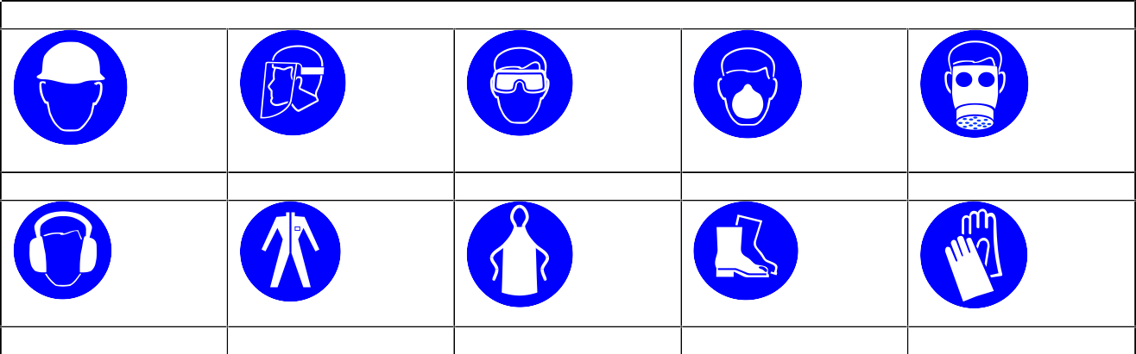
Suitable extinguishing media: Not flammable. Use media suitable for surrounding fire
PERSONAL PROTECTIVE EQUIPMENT REQUIREMENT. (tick as appropriate)
Hard Hats
Face Protection
Eye Protection:
Dust Mask: √ √√
Respirator
Ear Protection
Overalls
Apron
Foot Protection √
Gloves: √

Type of PPE & Model Nos |  |  | Type of PPE & Model Nos
Safety Glasses EN166 – if risk of splashing |  |  | Gloves – EN374 Chemical resistant - if prolonged exposure
Who orders PPE? | Specialist team manager
EMERGENCY CONTROLS
First Aid: Eyes |  | Bathe the eye with running water for 15 minutes. Get medical attention if irritation
Skin |  | Remove all contaminated clothes and footwear. Wash immediately with plenty of soap and water.
Inhalation |  | Remove casualty from exposure ensuring one’s own safety whilst doing so.
Ingestion |  | Wash out mouth with water. Do not induce vomiting. If Conscious, give half a litre of water to drink immediately. Consult a doctor
Dealing with spillage: |  | Small spillage: Flush away with plenty of water  Large spillage: Absorb into dry earth or sand. Transfer to a closable, labelled salvage container for disposal by an appropriate method
Disposal: |  | Empty containers to be collected as instructed by area manager
Precautions already in place: |  | PPE, Method statements, Induction and on-going training
Advice available from? |  | Evans Vanodine

2

