

COSHH ASSESSMENT SHEET
Date of Assessment: 03.12.2025 Assessment No: CSH 11 Assessor: Daniel Looney
Overall Assessment Rating of Risk [ √ ] Low [√ ] ] Medium [ ] High [ ]

Work Activity: Glass Cleaning
Persons at Risk: |  |  |  | User [√ ] Colleagues [√ ] Contractors [ ] Public [ ] Others [ ]
Name of Hazardous Substance: |  |  |  |  | UH10 Window and Glass cleaner
Manufacturer (address/tele no): |  |  |  |  | Unico Ltd  North Main Street  Carronshore  Falkirk  FK2 8HT
SDS Version: |  |  |  |  | 5
Supplier (address/tele no): |  |  |  |  | 01324 573410
Hazard data sheet attached: |  |  |  |  | Yes [√ ] No [ ]
Description/colour: |  |  |  |  | Clear
 | Container size in litres/kg |  |  |  | 20  litre/kg |  |  | 10  litre/kg |  |  |  | 5 litre/kg |  |  | >litre/kg |  | < litre/kg |  | Other
 | (tick as appropriate) |  |  |  |  |  |  |  |  |  |  | √
HAZARDS
Not classified

 | 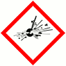 | 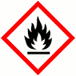 | 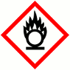 |  |  |  | 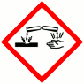 |  | 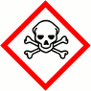 |  |  |  | 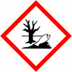 |  |  |  | 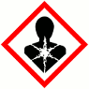 |  | 
 | Explosive (Symbol: exploding bomb) | Flammable (Symbol: flame) | Oxidising (Symbol: flame over circle) |  |  |  | Corrosive (Symbol: Corrosion) |  | Acute toxicity (Symbol: Skull and crossbones) |  |  |  | Hazardous to the environment (Symbol: Dead tree and fish) |  | Health hazard/  Hazardous to the ozone layer (Symbol: Exclamation mark) |  | Serious health hazard (Symbol: health hazard) |  | Gas under pressure (Symbol: Gas cylinder)
Known exposure levels:  W.E.L. (where applicable) |  |  |  |  |  | None specified
Likely route of entry to body:  (tick all that apply) |  |  |  |  |  | Inhaled |  |  |  | Ingested |  |  |  | Absorbed by skin |  | Eyes |  | Other
 |  |  |  |  |  | √ |  |  |  |  |  |  |  | √ |  | √
Areas of use/exposure: |  |  |  |  |  | Glass cleaning

CONTROL MEASURES
Can the exposure/use be eliminated or substituted? | (tick as appropriate) | Yes | No √

Is monitoring required? | (tick as appropriate) |  |  | Yes |  | No √
Local exhaust ventilation required? | (tick as appropriate) |  |  | Yes |  | No √
Documented working method available on safe use and handling? | (tick as appropriate) |  |  | Yes √ |  | No
Storage: | Maximum amount to be stored on site | Secure store out of reach of service users and children | Store to be well ventilated |  | Separate storage facility available or required |  | Other
(tick all that apply) |  | √ | √
Method of use. | Use undiluted | Use diluted | Wash hands after use |  | Do not mix with other products |  | Special precautions
(tick all that apply) |  | √ | √ |  | √
State any special/storage requirements or other precautions not listed above:
Water spray, dry powder, foam and carbon dioxide
Keep in closed container.
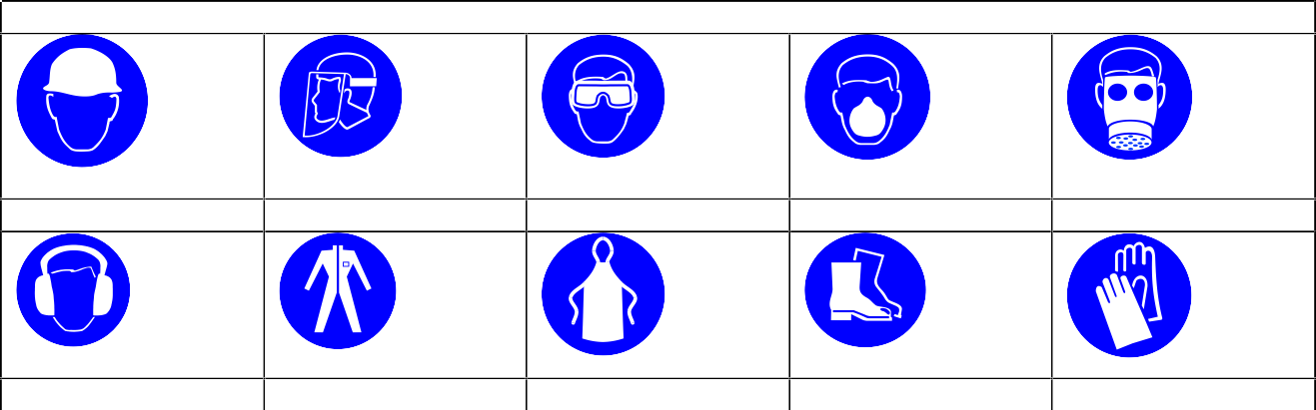
PERSONAL PROTECTIVE EQUIPMENT REQUIREMENT. (tick as appropriate)
Hard Hats
Face Protection
Eye Protection √
Dust Mask
Respirator
Ear Protection
Overalls
Apron
Foot Protection
Gloves

Type of PPE & Model Nos |  |  | Type of PPE & Model Nos
Safety glasses EN 166
Who orders PPE? | Area Manager
EMERGENCY CONTROLS
First Aid: Eyes |  | Check for and remove contact lenses. Rinse thoroughly with plenty of water.
Skin |  | Rinse skin immediately with plenty of water
Inhalation |  | Move person to fresh air at once. Keep comfortable for breathing. Get medical attention if any discomfort continues.
Ingestion |  | Rinse mouth and do not induce vomiting
Dealing with spillage: |  | Absorb using sand or earth. Contain spills to prevent migration
Disposal: |  | Empty containers to be disposed using authorised hazardous waste contractor
Precautions already in place: |  | PPE, method statements, induction & on-going training
Advice available from? |  | Unico

2

