

COSHH ASSESSMENT SHEET
Date of Assessment: 04.02.2025 Assessment No: CA 10 Assessor: Daniel Looney
Overall Assessment Rating of Risk [ √ ] Low [√ ] Medium [ ] High [ ]

Work Activity: |  |  |  |  |  |  |  |  |  |  | Cleaning metals and removing stains and scale.
Persons at Risk: |  |  |  | User [√] Colleagues [√] Contractors [ ] Public [ ] Others [ ]
Name of Hazardous Substance: |  |  |  |  | Jack’s Magic, The Pink Stuff
Manufacturer (address/tele no): |  |  |  |  | Jack’s Magic Products, Inc  12435 73rd Court  Largo, FL 33773  United States of America
SDS Version: |  |  |  |  | 2019
Supplier (address/tele no): |  |  |  |  | 800-424-9300
Hazard data sheet attached: |  |  |  |  | Yes [ √ ] No [ ]
Description/colour: |  |  |  |  | Pink
 | Container size in litres/kg |  |  |  | 20  litre/kg |  |  | 10  litre/kg |  |  |  | 5 litre/kg |  |  | >litre/kg |  | < litre/kg |  | Other
 | (tick as appropriate) |  |  |  |  |  |  |  |  |  |  |  |  |  |  |  | √
HAZARD (tick all that apply)
 | 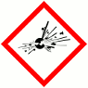 | 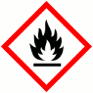 | 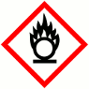 |  |  |  | 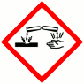 |  | 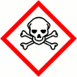 |  |  |  | 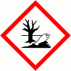 |  | 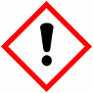 |  | 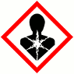 |  | 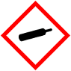
 | Explosive (Symbol: exploding bomb) | Flammable (Symbol: flame) | Oxidising (Symbol: flame over circle) |  |  |  | Corrosive (Symbol: Corrosion) |  | Acute toxicity (Symbol: Skull and crossbones) |  |  |  | Hazardous to the environment (Symbol: Dead tree and fish) |  | Health hazard/Hazard ous to the ozone layer (Symbol: Exclamation mark) |  | Serious health hazard (Symbol: health hazard) |  | Gas under pressure (Symbol: Gas cylinder)
 |  |  |  |  |  |  | √
Known exposure levels:  W.E.L. (where applicable) |  |  |  |  |  | None specified
Likely route of entry to body:  (tick all that apply) |  |  |  |  |  | Inhaled |  |  |  | Ingested |  |  |  | Absorbed by skin |  | Eyes |  | Other
 |  |  |  |  |  | √ |  |  |  |  |  |  |  | √ |  | √
Areas of use/exposure: |  |  |  |  |  | The Pink Stuff helps prevent metal and mineral stains and scale in new pools and aids in removing stains and scale in older pools.

CONTROL MEASURES
Can the exposure/use be eliminated or substituted? | (tick as appropriate) | Yes | No √
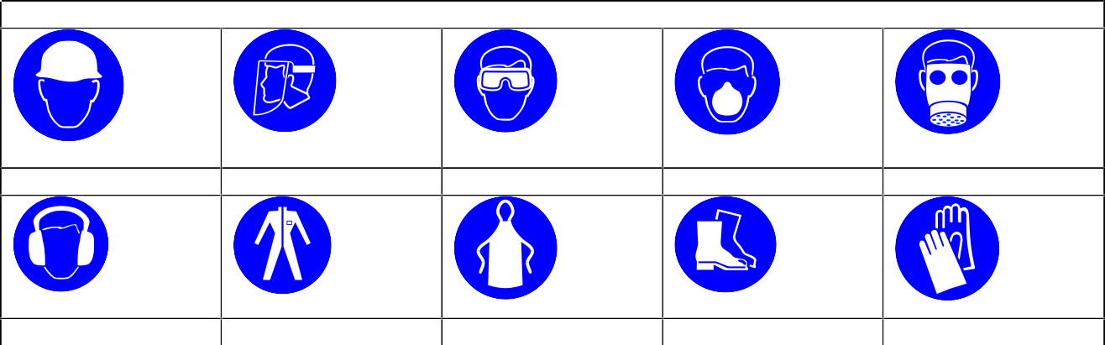
PERSONAL PROTECTIVE EQUIPMENT REQUIREMENT. (tick as appropriate)
Hard Hats
Face Protection
Eye Protection: √
Dust Mask
Respirator
Ear Protection
Overalls
Apron
Foot Protection
Gloves: √
Is monitoring required? | (tick as appropriate) |  |  | Yes |  | No √
Local exhaust ventilation required? | (tick as appropriate) |  |  | Yes |  | No √
Documented working method available on safe use and  handling? | (tick as appropriate) |  |  | Yes √ |  | No
Storage: | Maximum amount to be stored on site | Secure store out of reach of service  users and children | Store to be well ventilated |  | Separate storage facility available or required |  | Other
(tick all that apply) |  | √ | √
Method of use. | Use undiluted | Use diluted | Wash hands after use |  | Do not mix with other products |  | Special precaution s
(tick all that apply) |  | √ | √ |  | √
State any special/storage requirements or other precautions not listed above:
Suitable extinguishing media: Use media suitable for surrounding fire. Non Combustible

Type of PPE & Model Nos |  |  | Type of PPE & Model Nos
Safety Glasses EN166 |  |  | Gloves – PVC, Neoprene or natural rubber
Who orders PPE? | Area Manager
EMERGENCY CONTROLS
First Aid: Eyes |  | Rinse cautiously with water for several minutes. Remove contact lenses, if present and easy to do. Continue rinsing. Get immediate medical advice/attention.
Skin |  | Take off immediately all contaminated clothing. Rinse skin with water/shower. Get immediate medical attention. Wash contaminated clothing before reuse.
Inhalation |  | Not normally required. Treat symptomatically.
Ingestion |  | Wash out mouth with water. If conscious, give half a litre of water to drink immediately. Do not induce vomiting. Transfer to hospital as soon as possible.
Dealing with spillage: |  | Cover spills with inert absorbent material. Transfer to a container for disposal or recovery. Wash the spillage area with water. If possible prevent water running into sewer
Disposal: |  | Empty containers to be disposed of as hazardous waste
Precautions already in place: |  | PPE, method statements, induction & on-going training
Advice available from? |  | Jack’s Magic

2

