

COSHH ASSESSMENT SHEET
Date of Assessment: 04.02.2025 Assessment No: CA 06 Assessor: Daniel Looney
Overall Assessment Rating of Risk [ √ ] Low [√ ] Medium [ ] High [ ]

Work Activity: All Types of water washable surfaces Floors
Persons at Risk: |  |  |  | User [√] Colleagues [ √ ] Contractors [ ] Public [ ] Others [ ]
Name of Hazardous Substance: |  |  |  |  | E2 Eco- Dose Multipurpose Cleaner
Manufacturer (address/tele no): |  |  |  |  | Foremost Pro Ltd T/A Foremost. Unit 3 Dickinson Place, South Bersted Business Park, Bognor Regis, West Sussex,PO22 9QU.
SDS Version : |  |  |  |  | 10.4
Supplier (address/tele no): |  |  |  |  | 01243771340
Hazard data sheet attached: |  |  |  |  | Yes [ √ ] No [ ]
Description/colour: |  |  |  |  | Dark Blue
 | Container size in litres/kg |  |  |  | 20  litre/kg |  |  | 10  litre/kg |  |  |  | 5 litre/kg |  |  | >litre/kg |  | < litre/kg |  | Other
 | (tick as appropriate) |  |  |  |  |  |  |  |  |  |  |  |  |  | √
HAZARD (tick all that apply)
 | 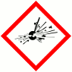 | 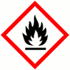 | 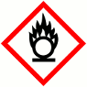 |  |  |  | 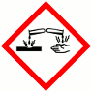 |  | 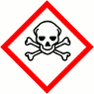 |  |  |  | 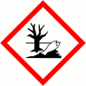 |  |  |  | 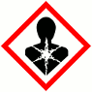 |  | 
 | Explosive (Symbol: exploding bomb) | Flammable (Symbol: flame) | Oxidising (Symbol: flame over circle) |  |  |  | Corrosive (Symbol: Corrosion) |  | Acute toxicity (Symbol: Skull and crossbones) |  |  |  | Hazardous to the environment (Symbol: Dead tree and fish) |  | Health hazard/Hazard ous to the ozone layer (Symbol: Exclamation mark) |  | Serious health hazard (Symbol: health hazard) |  | Gas under pressure (Symbol: Gas cylinder)
 |  |  |  |  |  |  |  |  |  |  |  |  |  |  | √
Known exposure levels:  W.E.L. (where applicable) |  |  |  |  |  | Not Specified
Likely route of entry to body:  (tick all that apply) |  |  |  |  |  | Inhaled |  |  |  | Ingested |  |  |  | Absorbed by skin |  | Eyes |  | Other
 |  |  |  |  |  | √ |  |  |  |  |  |  |  | √ |  | √
Areas of use/exposure: |  |  |  |  |  | Remove all dirt and grease from water washable surfaces

CONTROL MEASURES
Can the exposure/use be eliminated or substituted? | (tick as appropriate) | Yes | No √

Is monitoring required? | (tick as appropriate) |  |  | Yes |  | No √
Local exhaust ventilation required? | (tick as appropriate) |  |  | Yes |  | No √
Documented working method available on safe use and handling? | (tick as appropriate) |  |  | Yes √ |  | No
Storage: | Maximum amount to be stored on site | Secure store out of reach of service users and children | Store to be well ventilated |  | Separate storage facility available or required |  | Other
(tick all that apply) |  | √ | √
Method of use. | Use undiluted | Use diluted | Wash hands after use |  | Do not mix with other products |  | Special precaution s
(tick all that apply) |  | √ | √ |  | √
State any special/storage requirements or other precautions not listed above:
Suitable extinguishing media: Carbon dioxide, dry powder, foam
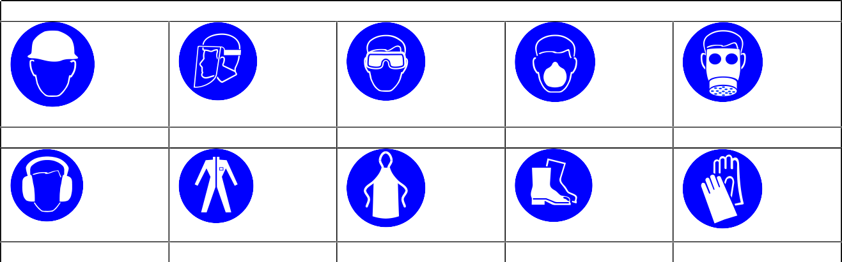
PERSONAL PROTECTIVE EQUIPMENT REQUIREMENT. (tick as appropriate)
Hard Hats
Face Protection
Eye Protection: √
Dust Mask
Respirator
Ear Protection
Overalls
Apron
Foot Protection
Gloves: √

Type of PPE & Model Nos |  |  | Type of PPE & Model Nos
Safety Glasses EN166 |  |  | Chemical resistant gloves EN374
Who orders PPE? | Area Manager
EMERGENCY CONTROLS
First Aid: Eyes |  | Promptly wash eyes with plenty of water while lifting the eyelids. Continue to rinse for several minutes. Get medical attention if any discomfort continues.
Skin |  | Remove affected person from source of contamination and remove  contaminated clothing. Rinse skin immediately with lots of soap and water. Get medical attention if irritation persists.
Inhalation |  | Move exposed person to fresh air at once. Rinse mouth and nose with water. Get medical attention if any discomfort continues.
Ingestion |  | Do not induce vomiting. Remove victim immediately from source of exposure. Drink nothing or little water. Get medical attention.
Dealing with spillage: |  | Soak up spillage with inert solids such as clay
Disposal: |  | Empty containers to be disposed of as hazardous waste.
Precautions already in place: |  | PPE, method statements, induction & on-going training
Advice available from? |  | Foremost

2

